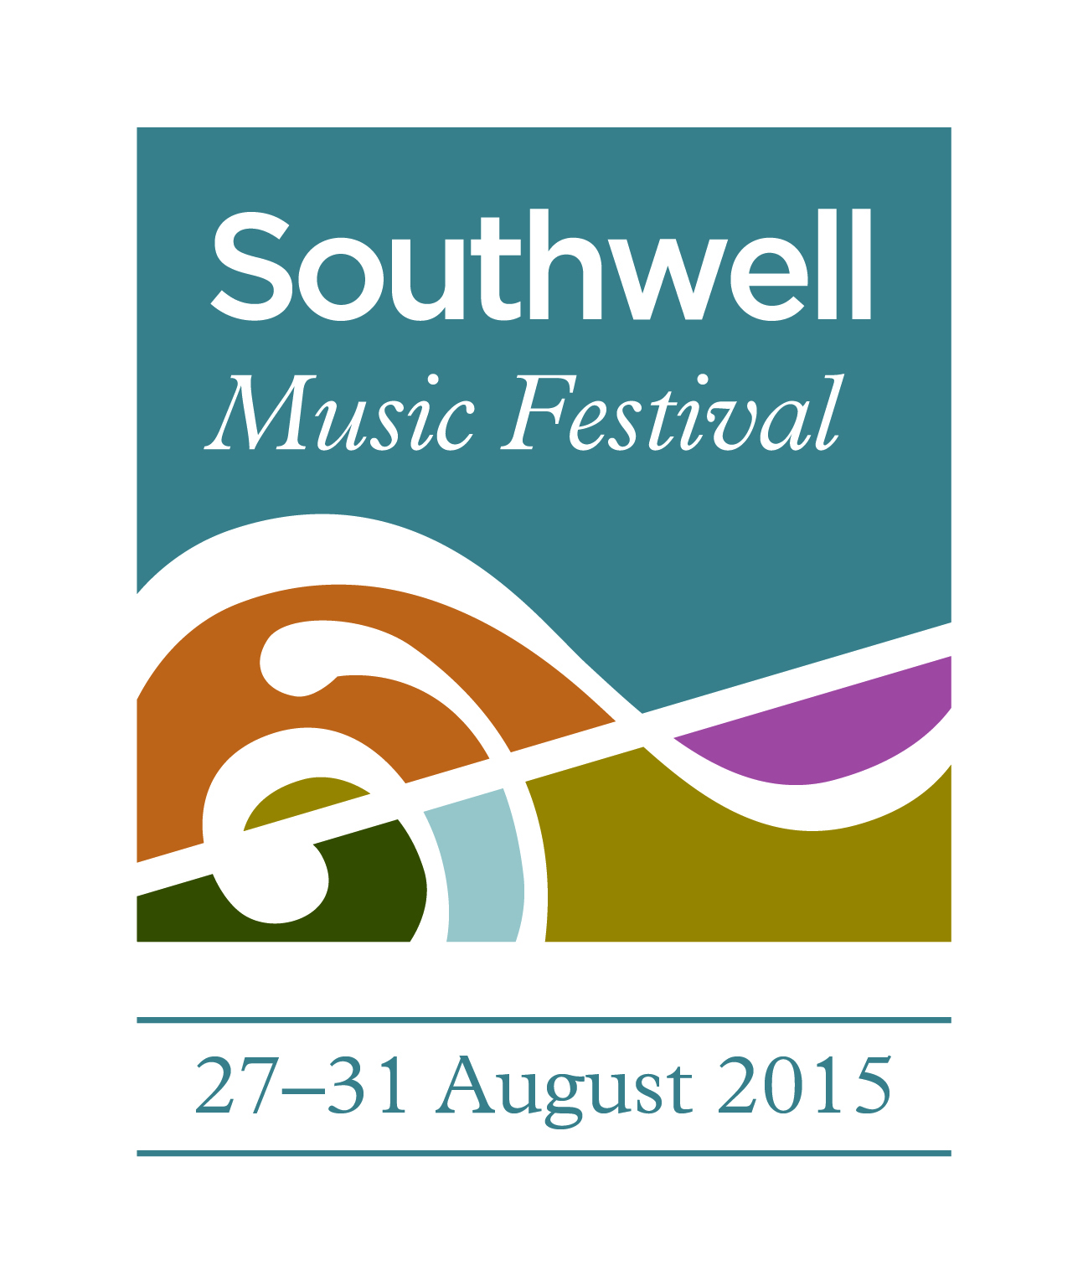

PRESS RELEASE
13 August 2015

MUSICAL STARS DESCEND ON SOUTHWELL

The small cathedral town of Southwell in Nottinghamshire is preparing to receive around 80 of the UK’s best professional classical musicians to sing and play in the second Southwell Music Festival across the August Bank Holiday weekend.

Following the success of last year’s inaugural Festival, the 2015 Festival will last five days (27-31 August) and comprise 24 musical events of which more than half are free, with associated exhibitions and fairs taking place around the town.

The centrepiece is a performance of Mendelssohn’s great oratorio Elijah to be given in Southwell Minster on Saturday 29th August at 7.30pm.

It is a musical setting of the dramatic Old Testament story of how the prophet Elijah stood up for the God Jehovah against the pagan gods worshipped by the Israelites: Mendelssohn’s admiration for JS Bach and the oratorios of Handel is reflected in rousing choruses, solo arias of great beauty and magnificent orchestral effects to conjure up the flood and fire which are God’s answer to Elijah’s prayer. The Elements provide a theme for much of the Festival’s music.

Elijah will be performed by an 80-strong professional choir and orchestra – a body of musicians whose sound alone will make quite an impact. The team of outstanding soloists is led by Andrew Foster-Williams (Elijah) who now performs throughout the world, and soprano Sarah Tynan who comes to Southwell immediately after appearing at New York’s Avery Fisher Hall.

The performance of Elijah will be conducted by Festival Founder and Artistic Director Marcus Farnsworth. Marcus who was a chorister at the Minster and is now one of the UK’s most highly-regarded young baritones.

Marcus says: “Elijah is one my great favourites from the oratorio repertoire and I have performed it on numerous occasions – as a member of the choir, as a conductor, and in the part of Elijah (though never all at once!). I am swept away by the drama of the piece every time. It is a real showpiece for all involved – soloists, choir and orchestra – and therefore it's a wonderful way of making the most of all our talented Festival Artists. I also think the Minster's unique acoustic will suit it perfectly.”

Late night concerts in the special atmosphere of the Minster after dark were a great success at the first festival and this year there will be two.

On Thursday 27th August at 10pm, a sequence of words and music entitled Voices on Water celebrates the power and beauty of water – picking up on the Elements theme. It is performed by the brilliant Southwell Festival Voices with actress Victoria Newlyn providing the readings and includes three of the most challenging and rarely-performed works in the 20th choral repertoire.

Richard Rodney Bennett’s Sea Change conjures up a seascape, Poulenc’s Un soir de neige offers snowbound solitude while Eric Whitacre’s Cloudburst (which was performed at the BBC Proms last weekend) is a breathtaking journey through the eye of a storm. Eric Whitacre has sent his good wishes in a special video message.

Marcus says: “These are three great peaks of the 20th century choral repertoire that I have wanted to perform for ages but until now have not had a choir equal to the challenge. It should be quite a ride.”

The following evening (Friday 28th August, 10pm) the Southwell Festival Chamber Soloists and reader Owen Sparkes perform a unique work in the string quartet repertoire but entirely appropriate for performance in the Minster. The Seven Last Words of Our Saviour on the Cross is Joseph Haydn at his most profound and most revolutionary: a meditation on each of the seven words closing with a musical representation of the earthquake (those elements again) which followed the death of Jesus.

On Saturday 29th August (4.30pm, Southwell Methodist Church) the Festival’s Patron Dame Felicity Lott will be in conversation with Sunday Times chief music critic Hugh Canning about her life and work – a story of outstanding musical achievement across five decades on the concert platform, in the opera house and recording studio. It will be illustrated by extracts from some of her very many recordings.

Marcus says: “Dame Felicity is one of our greatest living sopranos – a true national treasure. She remains an inspiration to younger singers like myself and we are honoured that she is one of our Festival Patrons. It is wonderful that she is taking time out of her busy schedule to attend the Festival and even more wonderful that she has kindly agreed to take part.”

Tickets for Elijah, the late night concerts and the conversation with Dame Felicity Lott are available from the Cathedral Shop on Church Street, Southwell (01636 812933).

In addition to Southwell Minster the Festival’s main concert venues are The State Chamber of the refurbished Archbishop’s Palace, which the Sunday Times chief music critic Hugh Canning last year described as “perfect for chamber music and song”, and The Stage at The Old Theatre Deli – a small Georgian theatre in the centre of Southwell.

Among the Festival’s sold out concerts are two performances of music by the 19th century composer Franz Schubert (The State Chamber, 27 and 28 August) including songs to be performed by Marcus Farnsworth and soprano Alison Rose who last weekend became Mrs Farnsworth in Southwell Minster. These concerts will be their first appearance together on stage as man and wife.

Other sold out concerts in the State Chamber include a recital by the 25 year old Indian pianist Julian Clef (Saturday 29th August) who was discovered by Mrs Linda John from Mansfield and who has since supported his career. Also, on Sunday 30th August a programme of 20th century chamber music includes a rare performance of Stravinsky’s most famous orchestral ballet score The Rite of Spring in an arrangement for two pianists at one piano. The performers are the Festival’s ‘house’ pianists James Baillieu and Libby Burgess.

Libby says: “I’ve known and loved The Rite for many years and have always envied orchestral players who perform it. I’m very excited about this unusual chance to do so in the piano duet reduction made by the composer – and about the enormous glass of wine we’ll be needing afterwards!”

The 13 free events in the Festival are centred on the five fringe concerts: these feature young and local musicians including pupils from the Minster School and take place throughout the town centre – outside the Old Theatre Deli and the Admiral Rodney, at Southwell Methodist Church and in the Walled Garden of the Archbishop’s Palace.

In addition the free events include four services in the Minster on Sunday and Monday with special musical content, a masterclass in which local young musicians are tutored in public by visiting professionals (Saturday 29th, 10am, State Chamber), and an informal performance of Mozart’s Requiem (Monday 31st, 2pm, The Minster) featuring a choir of more than 200 amateur singers with visiting professionals who will have gathered earlier in the day to rehearse the piece. This Come and Sing event is supported by the Nottinghamshire Arts Fund.

Two of the Minster’s regular free concerts also contribute to the Festival programme – the lunchtime recital (Friday 28th, 12.15pm) featuring local cellist Sarah Huson-Whyte performing with her piano trio, and the Bank Holiday organ recital (Monday 31st, 3.30pm) given by Sub-organist at Westminster Abbey Daniel Cook.

Alongside the musical programme are a variety of exhibitions and other events:
- The Southwell Artists group comprising local professional artists contribute a free exhibition of work either depicting or on the theme of music (27-31 August, The Minster) www.southwellartists.co.uk
- The Artists have also organised a Musical Draw at which members of the public can draw Festival musicians rehearsing (Saturday 29th August, 10am-1pm, The Minster)
- A rare chance to visit Southwell Minster’s historic library (Monday 31st August, 10.30-3.30pm). Admission is free but please note access is up steep stairs and only children over the age of 7 will be admitted.
- A Craft Fair presenting handmade products by local craftspeople (Monday 31st August, 10.30-4.00pm, Market Square)
- The final days of Sculpture in the Sanctuary at Reg Taylor’s Garden Centre at Normanton (1-31 August) www.sculptureinthesanctuary.co.uk
- An Antiques Collectors and Vintage Fair at Southwell Racecourse organised by Field Dog Fairs (30-31 August, 9.30-4.00pm) www.fielddogfairs.com

In addition the Education Garden at the Archbishop’s Palace will be open from 9am-7.30pm throughout the Festival, admission free.

Details of all events in the Festival can be found at www.southwellmusicfestival.com and will be contained in a special souvenir programme book available from the Minster Shop from 22nd August.

Founder and Artistic Director Marcus Farnsworth concluded: “I was brought up in Southwell and love the town and especially the Minster. It has always disappointed me that the place is not better known and the Festival, which is a charity and organised entirely by volunteers, is one way to address that.

“I am delighted that so many people support the idea with great generosity: we have sponsors for nearly every concert this year, led by once again by Mr Geoffrey Bond as overall 2015 Festival Sponsor.

“We are indebted to well over 200 people and organisations who have given funds or volunteered their time or resources to make the Festival happen, as well as to our brilliant visiting musicians – all of whom are generously hosted by local people.

“We are most grateful to the Dean and Chapter at Southwell Minster for allowing us to use the Minster and the State Chamber, without which the Festival could not take place.

“Last year one audience member remarked that ‘Music has been set alight in Southwell!’ We look forward to rekindling the flame.”

To help raise funds for the next Festival, the sponsor of Elijah Clarke Associates Wealth Management have organised a prize draw with a prize (worth £750) of two tickets to Bizet’s Carmen at the Royal Opera, Covent Garden on Saturday 7th November, and a night for two at a five star hotel nearby. Tickets, price £10, will be on sale throughout the Festival and the draw will be made at the Mozart Requiem performance on August Bank Holiday Monday afternoon.

ends

Further information:

Southwell Music Festival: Chris Senior 07811 742362
Southwell Artists: Maggy Milner 07710 515699
Craft Fair: Sarah Payne 01636 819038
Sculpture in the Sanctuary: Helen Barry 01636 813184
Antiques Collectors & Vintage Fair: Field Dog Fairs 07772 349431
Southwell Minster: Jane Wyles 01636 817243

Other useful websites:

Southwell Music Festival www.southwellmusicfestival.com
Southwell Minster www.southwellminster.org
The Archbishop’s Palace www.archbishopspalacesouthwell.org.uk

